Stove Emissions and Efficiency Testing Laboratory
Ulaanbaatar, Mongolia

Contact: Prof Lodoysamba, 99-18-35-46
Lodoysamba@num.edu.mn

STOVE TEST REPORT

Test Number______081______ Date___2010-08-22___ Test requested by: __ADB_____________

- PRODUCT DESCRIPTION

Stove Name __Traditional_ Stove manufacturer __Street_______ Stove provided by ___ADB______

Notes about stove: This is a traditional stove in good condition operated in a traditional manner with coal having been dried through the summer in the laboratory. It is a quick investigation to see of the PM and CO are affected by the drying of the fuel alone with no other changes in technique.

Combustion type _Bottom-lit updraft___ Intended application for the stove _____Heating/cooking_
(updraft/ cross draft/ downdraft/ gasifier) (heating/cooking/low pressure boiler/wall stove)

Fuels specified for use in this product __Nalaikh raw coal broken to about 25/35 mm_____

Lighting method suggested by the manufacturer:

A wood fire is lit at the front and some coal placed upon it when it is burning well. When that coal is lit, more is added. It is the standard operating technique for traditional stoves.

- FUEL DESCRIPTION

  - Name ____Nalaikh raw coal_________________

  - Source ____On the street____________________

  - Analysis performed by __C Pemberton-Pigott_

  - Heating Value: Lower Heating Value (LHV)__17.12__ MJ/kg and As Received __16.55__MJ/kg

Analysis As Received (AR)
Moisture % As Received (AR) | 20.70 | % WWB
Ash % | 6.34 | % Wet Basis
Sulphur % | 0.46 | % Wet Basis, Ash in
Hydrogen % | 4.19 | % Wet Basis, Ash in
Carbon % | 56.30 | % Wet Basis, Ash in
Oxygen % | 10.75 | % Wet Basis, Ash in
Nitrogen % | 1.25 | % Wet Basis, Ash in

- PHOTOGRAPHS OF THE BASELINE STOVE

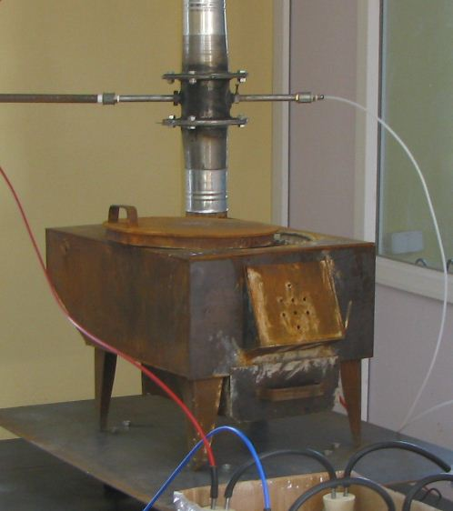
Typical traditional Mongolian cooking and heating stove with a sheet metal top.

- TEST DESCRIPTION
Stove operated by ____Tseyen-Oidov___________ Data recorded by ___Crispin+Lodoysamba+ Oidov_

Test Protocol used Standard, without refuelling_ Starting time _11:00 AM__ Ending time __14:27 PM___

Lighting procedure used __As above______________________________________________________

___________________________________________________________________________________

Notes about the environment during the test :

PM 2.5 about 45 microgrammes per cubic metre in the laboratory air, a typical summer level.
___________________________________________________________________________________

- TEST RESULTS, SUMMARY

  - Data analysis sheet version number used _ _2.59.4_____

  - Summary results

    - Fuel loaded during first burn, g _ 3,800_____

    - Burn time, minutes_______________ 73_____

    - Fuel loaded during refuelling, g__ 2378 ____

    - Refuelling burn time (minutes) _ _ 125 _____

    - Percentage of fuel burned when analysis of the test ended ___90%______

    - kW (average) during whole burn __ _________5.38__ kW

    - PM2.5 per Net MegaJoule of heat produced 794.28 milligrammes

    - CO emitted per Net MegaJoule of heat produced 16.61 grams

    - Notes about summary results:

This is a typical burn cycle for a medium-sized ger stove. The power level ramped rapidly and the coal mostly burned out in just over an hour. There is a very high peak power followed by a rapid collapse.

    - Notes about the operation of the stove during the test:

Nothing special.
________________________________________________________________________

- DETAILED RESULTS AND CHARTS

  - POWER and FUEL CONSUMPTION

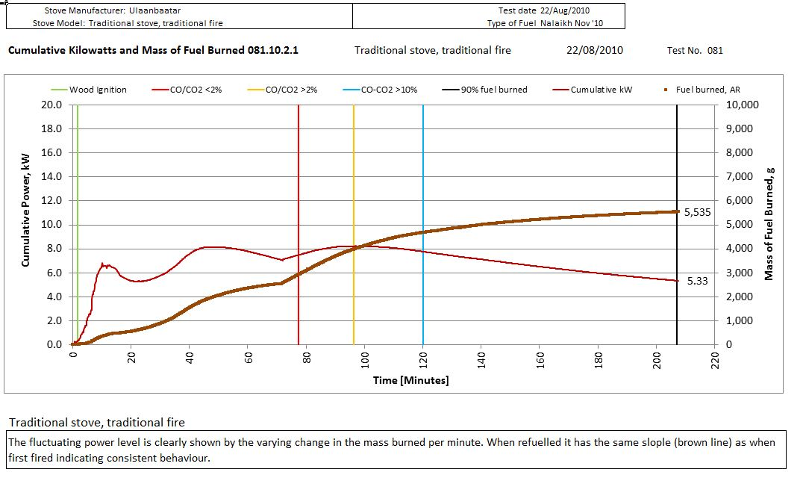

  - COMBUSTION EFFICIENCY AND GAS EMISSIONS

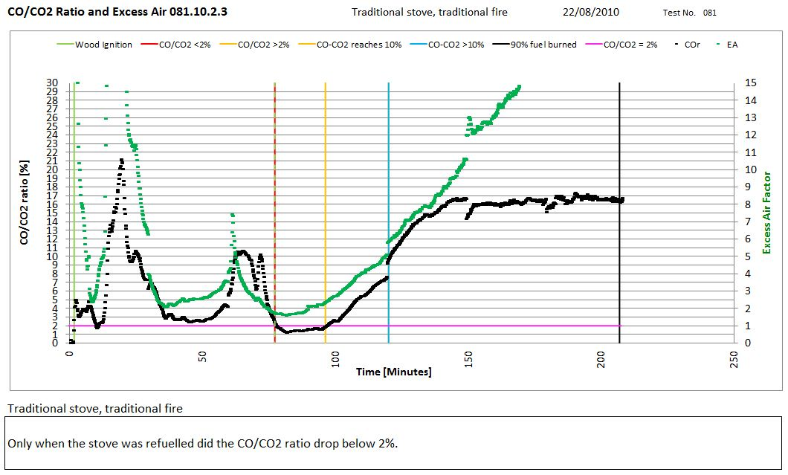

  - THERMAL EFFICIENCY OF HEATING AND COOKING

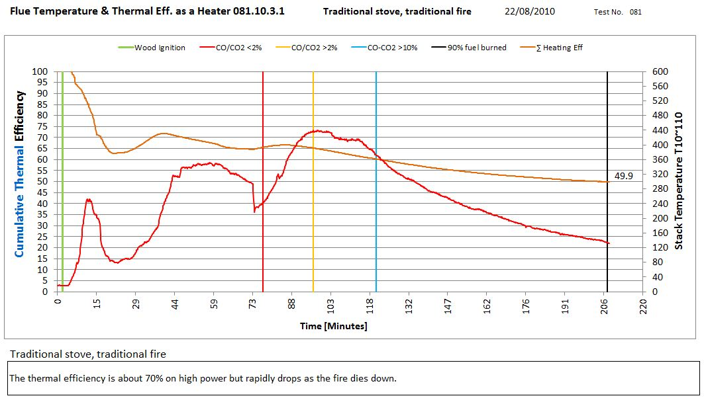

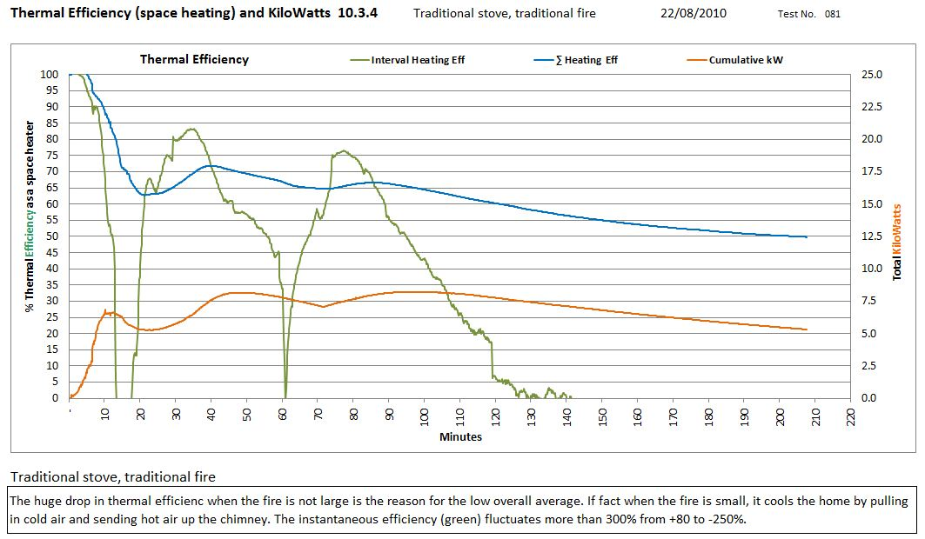

  - PARTICULATE EMISSIONS

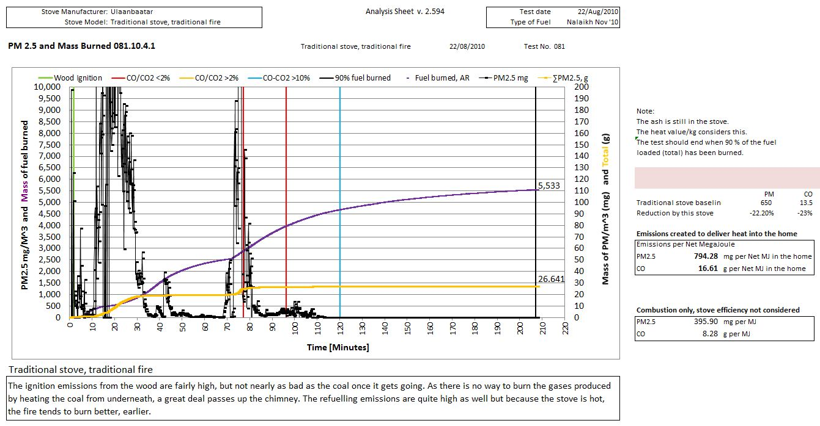

  - PERFORMANCE

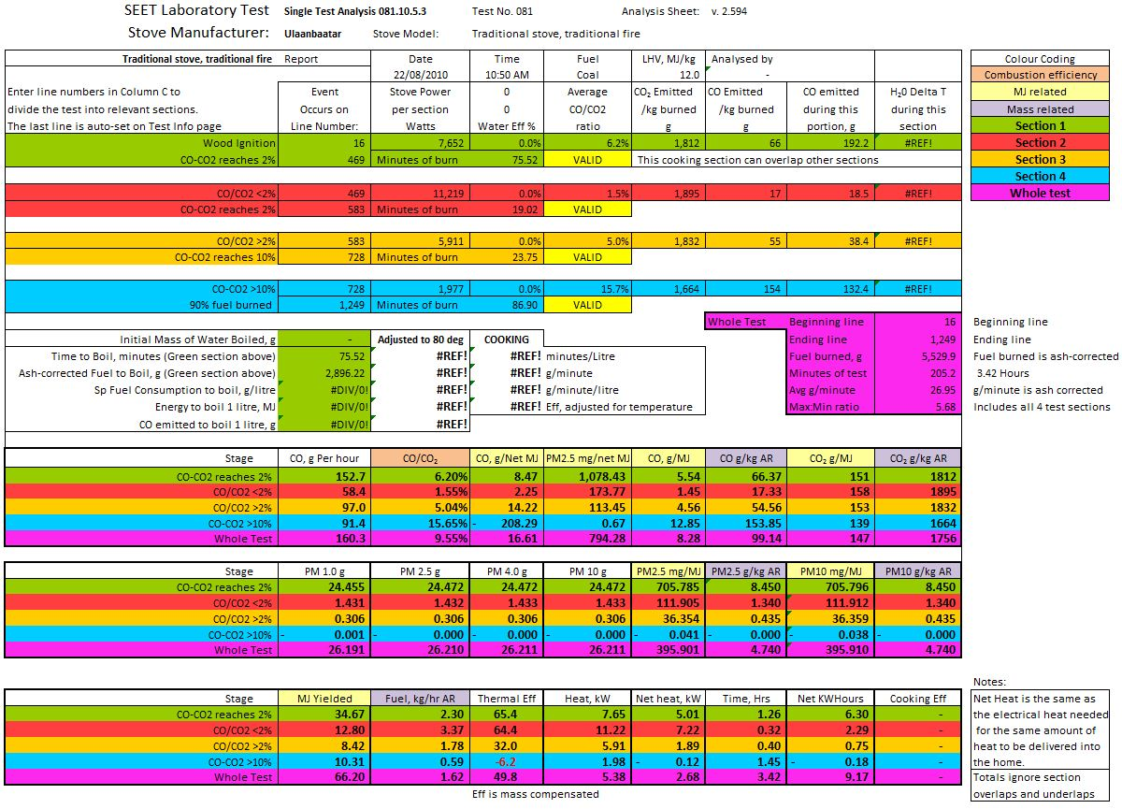

6.6 TEST INFORMATION

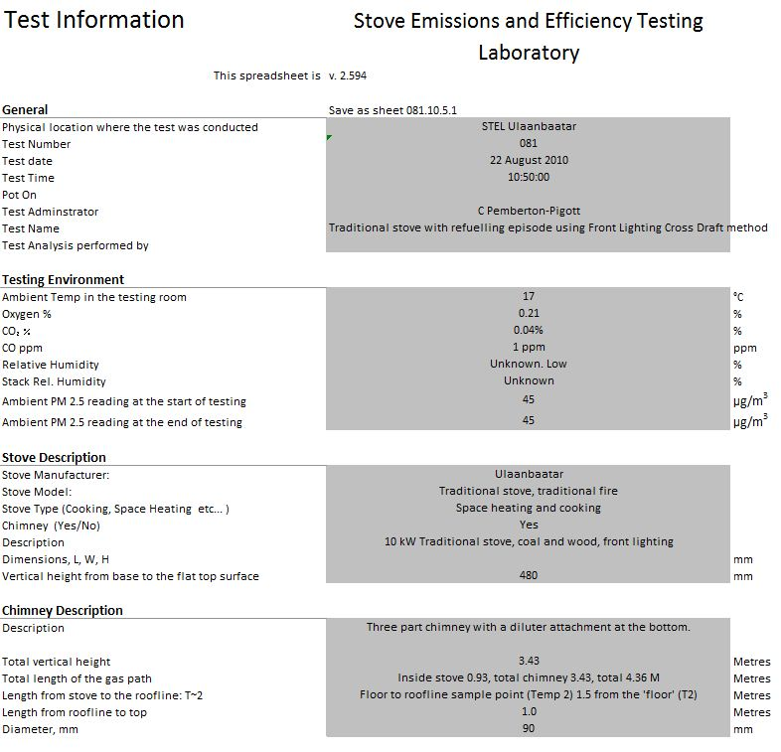

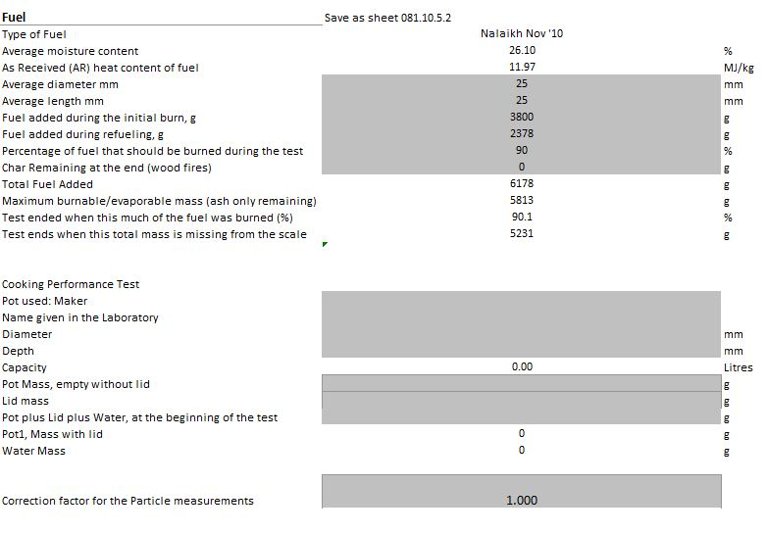

6.7 WATER BOILING

- DISCUSSION
  - The test shows that the traditional Mongolian coal stove lights relatively easily but uses rather a lot of wood doing so. Enough wood much be used so that then the coal is placed on top of it, it continues to burn. The heat output is large initially then dies away rapidly giving a typical too-hot then too-cold cycle.
  - The PM is largely produced during the ignition process as well as the refuelling that takes place later when the stove is hot. The hot stove develops a good fire sooner than when the stove is cold. In both cases the smoke of smoke is prodigious. The excess air ratio is too high which leads to large losses of heat when the fire is small and the generation of a great deal of CO. CO is partially burned carbon and represents a significant additional loss.
  - The stove appears to be well made. It is a new stove and was run expertly. It is assumed that the emissions will be higher if it is not operated as well. It can be produced in large numbers and this is the dominant stove type found in the ger communities.
  - The cooking ability was not tested at this time. Earlier tests indicated the cooking efficiency is about 15%. This is low and is typical of a well-managed open fire. The cooking power is very high after about 40 minutes which is appreciated by the cooks in Mongolia. The pot sits properly into the hole provided. There are no rings to suit smaller pots.
  - It is expected to save about 30% of the fuel normally used.
  - The traditional stove is the baseline so it constitutes the emissions against which other stoves will be compared.
  - The average power during the test period was 5.38 kW. With the thermal efficiency factored in, it delivers 2.68 kW into the home. There is a small heat exchanger on the back of the stove which is too small to effectively pass heat into the home. As a result the chimney temperature is often very high.
  - There should be no durability issues with the steel components because the interior of the stove is lined with bricks and clay. A typical life is 5 to 10 years.

